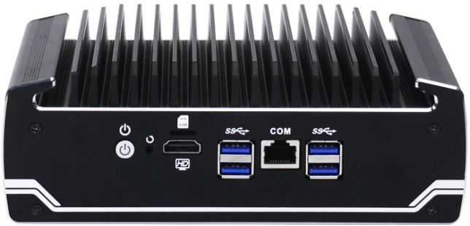

N18

Features：
◇ All aluminum structure，Fanless design；
◇ Onboard Intel 8th Generation Core i5/i7；
◇ Support 2*DDR4 RAM Slot，Max Support 32G；
◇ Support 1* MSATA，1*2.5”SATA；
◇ Support 6* Intel 1000 M Lan；
◇ Support 1* RJ45 COM（Support Console）；
◇ Applied O/S：

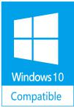
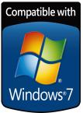


Specification
Model | IBOX-501 N18
Color | Black (Color can be customized)
Material | High-quality all aluminum，Surface anodic oxidation
Processor | Onboard Intel Celeron 3867U（Dual core, dual threads，1.8G，2MB Cache）；
Processor | Ondoard Intel Core i5 8250U（quad core,8 threads,1.6G，Max.Turbo 3.4G,6MB Cache）；
Processor | Onboard Intel Core i7 8550U（quad core,8 threads, 1.8G，Max.Turbo 4.0G,8MB Cache）
RAM | Support 2* DDR4 2133/2400 MHz SODIMM RAM slot，Max. 32 GB
Display Chip | Integrated Intel UHD Graphics 620
Display Port | 1* HDMI（No sound output）
Front I/O | 4*USB3.0，1*Power Switch，1*RJ45 COM（Support Console）,1* HDMI
Rear I/O | 6*RJ45 1000M Lan, 1*DC
Expansion | Support 1* half height MINI PCIE slot（WIFI/BT Optional）
Expansion | Support 1* Full height MINI PCIE slot（Suooport MSATA/4G，1* Nano-SIM slot on the plate）
Network | 6*Intel i211-AT 10/100/1000M LAN
Storage | 1*MSATA slot，1*2.5” HDD
Input Voltage | Support DC 12V Input
Other Function | Auto power on when there is electricity、Timing boot、Wake on LAN、PXE boot、Watchdog（0～255 level）
Work Temp | 0℃ ～ +50℃（Commercial HDD），-20℃ ～ +50℃（（Industrial SSD），Surface air flow
Work Humidity | 0% ～ 95% non-condensing
Certificates | CE、 CCC、 FCC Class A、 ROHS
Dimension | 186 * 126.5 * 66 mm
Net Weight | 1.3 kg
Application | Firewall，VPN，Network server，Network security，Router etc.

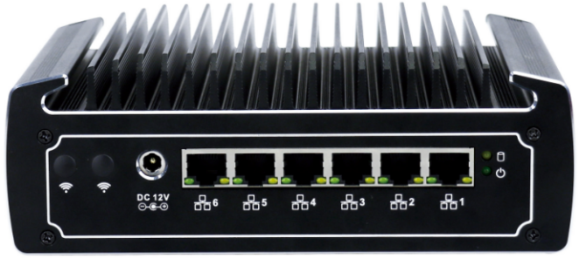
N18

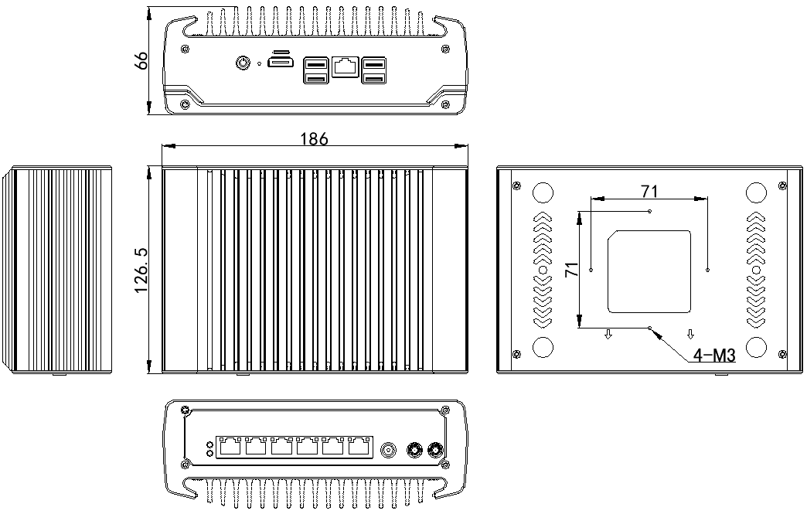
Accessory
Name | Quantity | Specification
Power Adapter | 1 | i5-8250U/12V 5A
Power Adapter | 1 | i7-8550U/12V 7.5A
Power Cord | 1 | Any Plug Optional  (China, US, EU, UK etc.)
Certificate of Approval | 1 | Neutral
Warrantly Card | 1 | Neutral
VESA Bracket | 1 | Standard
Order Information
Configuration 1 | N18 | Intel Celeron 3867U | Standard Port
Configuration 2 | N18 | Intel Core i5 8250U | Standard Port
Configuration 3 | N18 | Intel Core i7 8550U | Standard Port

